**Embedded Systems Design Lab**

**Experiment 4: PWM control of DC motor using potentiometer**

**Objective**: To control the speed of DC motor using PWM pulses. Duty cycle of the PWM is varied by using **potentiometer** connected to Launchpad.

**Components:** Tiva Launchpad, DC motor, L293D IC, 10K potentiometer, connecting wires.

**PWM:**

Pulse width modulation is a technique widely used in motor control systems. By varying duty cycle of a high frequency square wave, average value of the signal is varied.

Generate PWM pulses using SysTick timer. Provide appropriate duty cycle for the pulses. Duty cycle should vary from 50% to 95%.

**ADC:**

Analog to digital converter module in Tiva is used to determine digital equivalent of analog voltage. The analog voltage is varied by potentiometer from 0 to 3.3V. It’s a 12 bit ADC, so varies from 0 to 4096. Map this range to the appropriate duty cycle of PWM(50 to 95%).

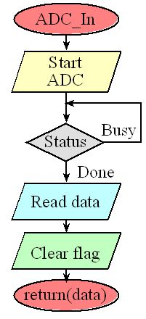

**Step 1.**The ADC is started using the software trigger.

**Step 2.** The function waits for the ADC to complete by polling the RIS register bit 3.

**Step 3.**The 12-bit digital sample is read out of sequencer 3.

**Step 4.** The RIS bit is cleared by writing to the ISC register.

The four steps of analog to digital conversion

A 12-bit successive approximation ADC

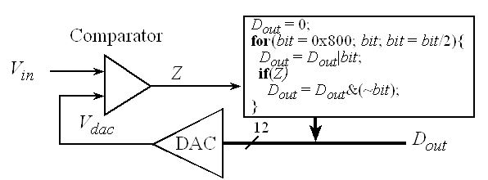

* For a range of 0 to 3.3v

 Digital Sample = (Analog Input (volts) • 4095) / 3.3V(volts).

Q1) If the input voltage is 1.5V, what value will the TM4C 12-bit ADC return?

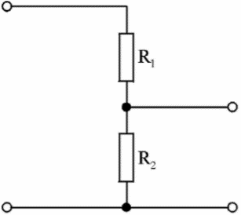 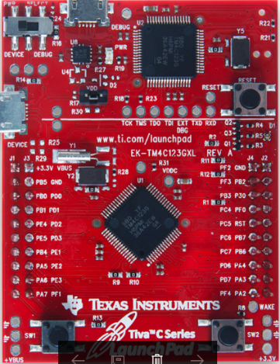 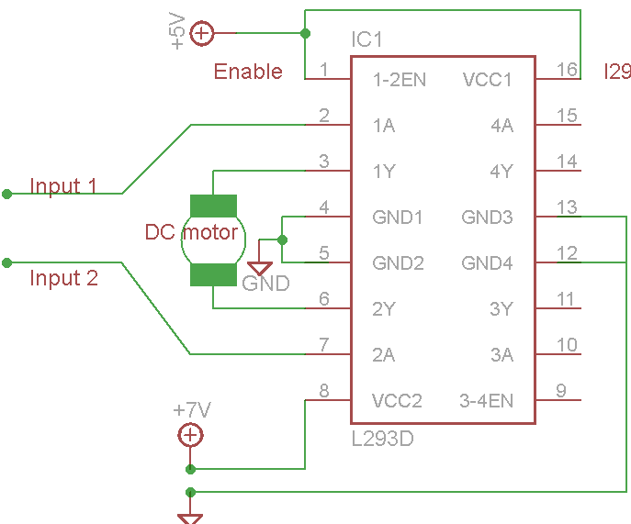

PE2

gnd

gnd

PF4

**Circuit diagram of dc motor control using ADC**.

**Exp1**: control the motor speed using potentiometer. (duty cycle of PWM should vary from 50% to 95%).

**Post-lab :** control the direction of the motor along with speed control (duty cycle of PWM should vary from 50% to 95%).